SOLO PROJECT - 1
RFI (Radio-Frequency Interference) Detection
Starting with the basics.....
What is Radio Frequency Interference (RFI)?
Radio Frequency Interference (RFI) is defined by radio astronomers as any radio signal not of cosmic origin that disturbs sensitive radio astronomy instrumentation and/or observations. This interference can be generated by human-caused sources such as communication signals or radio noise produced by electronic circuits. Because radio astronomers sweep across nearby bands that may be outside their allocated bands to follow the expansion of the Universe, their observations are susceptible to other radio transmissions, such as cell phones, television, Wi-Fi, walkie-talkies, Bluetooth devices, radio transmitters, and satellites. Human-caused radio transmissions produce much stronger signals than celestial sources do, and they can have a range of effects on radio astronomy, from loss of data due to contamination (such that increased observation time is required to obtain the same sensitivity) to actual hardware damage inflicted on sensitive receivers.
Frequency Allocations :
Spectrum regulation generally refers to the Radiocommunications Sector of the International Telecommunication Union (ITU-R) definitions of radio services (broadcasting service for TV; mobile service for cell phones; fixed-service for microwave data links; fixed-satellite and mobile-satellite services for SATCONS, and dozens of others) and the allocation of spectrum bands to particular services with rules for their use. Most spectrum bands are shared among several active services, but 2% of the spectrum below 86 GHz is in bands shared only among passive services, for example the 1400 – 1427 MHz band that is used to observe the 21cm line of HI in the local Universe. Although the passive bands originated with radio astronomy, their most important current use is by Earth-sensing satellites that measure soil moisture, ocean salinity and surface temperature, wind speeds, air turbulence, and other environmental parameters.
Spectrum Management
Since the radio spectrum is used for many different purposes, it is heavily regulated to prevent interference. The highest level of regulation occurs at the ITU-R. Within the United States, the Federal Communication Commission (FCC) regulates the radio spectrum for private users (including radio astronomy) and in spectrum that is shared between non-Federal and Federal users. Almost every ITU member country has its own analogous national administration.
Radio Quiet Zones
Geographic isolation is the most effective means of forestalling RFI from terrestrial radiocommunications. Radio quiet zones (RQZs) are remote areas where use of radio spectrum is specially managed to benefit radio astronomy. More than a dozen RQZs have been created world-wide. Unfortunately, RQZs are not yet recognized internationally, so protection from satellite and airplane signals is not guaranteed.
Mitigation Techniques
To mitigate the impacts of RFI on ground-based astronomy, astronomers employ measures such as shielding, filtering, RFI detection and processing in the data analysis phase, and careful site selection in remote regions with minimal sources of terrestrial interference, such as Radio Quiet Zones. For the most part, astronomers can track the location of satellite signals. Astronomers know the allocations and the locations of most transmitters which can help them to devise strategies to mitigate harmful interference. While the geosynchronous belt of satellites can typically be avoided, the burgeoning use of non-geosynchronous satellites presents new challenges. Radio astronomers are actively working with satellite operators to mitigate impacts on radio telescopes.
Impact of Large Satellite Constellations
Satellite constellations are groups of satellites working together to provide communications services such as broadband internet. Examples include Starlink and OneWeb, which transmit in multiple frequency bands across the radio spectrum ranging from 140 MHz to 76 GHz. These satellites can be troublesome to radio telescopes since they transmit signals orders of magnitude stronger than many of the astronomical signals. In other words, satellite transmissions produce an effect similar to pointing a flashlight in one’s eyes in a very dark room. It is estimated that within the decade, the number of satellites in Low Earth Orbit (LEO) (with altitudes of 300-1200 km and orbital periods of 60-90 minutes) may surpass one million in number.
What is Noise?
Noise is frequencies which you do not need in your work. Any frequencies which aren’t helpful in your projects are labelled as noise.
Source: https://compasse.aas.org/issues/radio-frequency-interference/
Fundamentals of RFI Mitigation in Radio Astronomy
RFI mitigation in radio astronomy involves identifying and removing or suppressing unwanted radio signals that can interfere with the detection of celestial radio waves. The fundamental principle of RFI mitigation is to distinguish between RFI and astronomical signals based on their characteristics, such as frequency, time, and spatial distribution.
RFI can be broadly classified into two categories: narrowband and broadband. Narrowband RFI is typically caused by transmitters operating at a specific frequency, while broadband RFI is caused by sources that emit over a wide frequency range, such as digital communication systems.
Types of RFI and Their Mitigation Challenges
Different types of RFI pose varying challenges for mitigation. Some common types of RFI include:
- Continuous wave RFI: Continuous wave RFI is a type of narrowband RFI that is emitted at a single frequency. It can be challenging to mitigate because it can be mistaken for a celestial signal.
- Pulsed RFI: Pulsed RFI is a type of RFI that is emitted in short bursts. It can be challenging to mitigate because it can be difficult to distinguish from celestial pulses.
- Broadband RFI: Broadband RFI is a type of RFI that is emitted over a wide frequency range. It can be challenging to mitigate because it can be difficult to distinguish from celestial signals.
Importance of RFI Mitigation for Data Quality
RFI mitigation is essential for maintaining the quality of radio astronomy data. RFI can cause a range of problems, including:
- Data contamination: RFI can contaminate radio astronomy data, making it difficult or impossible to detect celestial signals.
- Reduced sensitivity: RFI can reduce the sensitivity of radio telescopes, making it more difficult to detect faint celestial signals.
- False detections: RFI can cause false detections, which can lead to incorrect conclusions about celestial objects and events.
Overview of Existing RFI Mitigation Techniques
Some common RFI mitigation techniques include:
- Frequency filtering: Frequency filtering involves removing RFI by filtering out specific frequency ranges.
- Time-domain blanking: Time-domain blanking involves removing RFI by blanking out specific time ranges.
- Spatial filtering: Spatial filtering involves removing RFI by using multiple antennas to form a null in the direction of the RFI source.
Advanced Signal Processing Methods for RFI Removal
Advanced signal processing methods have been developed to remove RFI from radio astronomy data. Some of these methods include:
- Independent Component Analysis (ICA): ICA is a technique that separates mixed signals into their original sources. It can be used to remove RFI from radio astronomy data.
- Machine learning algorithms: Machine learning algorithms can be trained to identify and remove RFI from radio astronomy data.
- Wavelet denoising: Wavelet denoising is a technique that removes noise from signals by thresholding wavelet coefficients. It can be used to remove RFI from radio astronomy data.
Machine Learning and AI in RFI Mitigation
Machine learning and AI are playing an increasingly important role in RFI mitigation. Some ways in which machine learning and AI are being used for RFI mitigation include:
- RFI classification: Machine learning algorithms can be trained to classify RFI into different categories, enabling more effective mitigation.
- RFI detection: Machine learning algorithms can be trained to detect RFI in radio astronomy data, enabling more effective mitigation.
- RFI removal: Machine learning algorithms can be trained to remove RFI from radio astronomy data, enabling more effective mitigation.
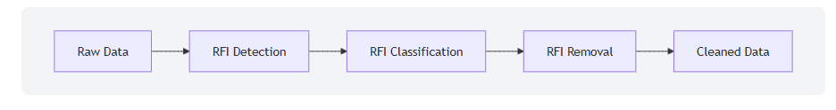
In a nutshell….
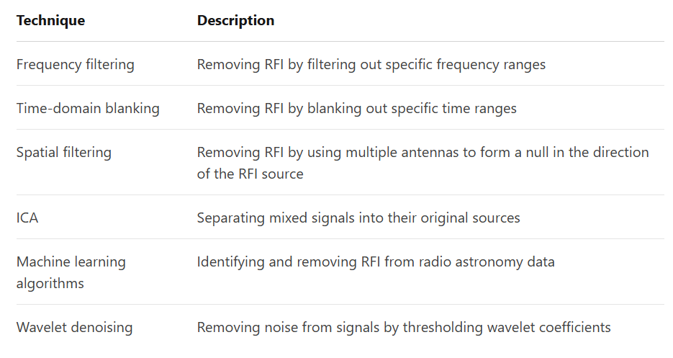
Source: https://www.numberanalytics.com/blog/rfi-mitigation-radio-astronomy
Problem Statement: The Challenge of RFI
Radio telescopes are designed to capture extremely weak radio waves from distant celestial objects. However, the terrestrial environment is increasingly filled with human-generated electromagnetic signals (RFI) from sources like mobile phones, Wi-Fi, television broadcasts, and radar. These RFI signals can be orders of magnitude stronger than astronomical signals, leading to:
- Data Contamination: Overwhelming the desired cosmic signal.
- Data Loss: Requiring the removal of affected data, reducing observation efficiency.
- Misinterpretation: Creating false signals or obscuring real astronomical phenomena.
Effective RFI mitigation is therefore crucial for maximizing the scientific output of radio observatories.
Project Approach
The project followed a standard machine learning pipeline:
Signal Simulation
To create a controlled environment for RFI detection, a synthetic radio signal was generated, consisting of:
- Clean Background Noise: Modeled as Gaussian white noise, representing inherent system noise and diffuse cosmic background.
- Simulated RFI: A strong sine wave (continuous wave RFI) introduced at a specific frequency (150 Hz) and amplitude. This RFI was intentionally injected only during predefined time windows (2-5 seconds and 6-8 seconds) to mimic intermittent interference.
- Observed Signal: The sum of the clean background noise and the injected RFI.
- Ground Truth Labels: A binary array (1 for RFI, 0 for no RFI) was created, perfectly aligning with the RFI injection times, serving as the "answer key" for the machine learning model.
Data Visualization
The simulated observed_signal was visualized in both the time and frequency domains to confirm the presence and characteristics of the RFI:
- Time Domain Plot: Displayed the signal amplitude over time, clearly showing the strong RFI bursts standing out from the background noise. The ground truth RFI locations were overlaid for visual verification.
- Frequency Domain Plot (Spectrum): Generated using a Fast Fourier Transform (FFT), this plot revealed a distinct power spike at the RFI's injected frequency (150 Hz), confirming its spectral signature.
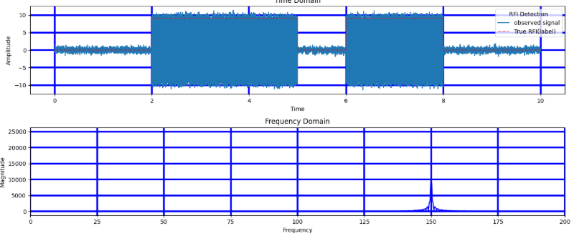
Feature Extraction
Raw time-series data is not directly suitable for most machine learning models. Therefore, statistical features were extracted from overlapping "windows" (50 samples wide, stepping by 25 samples) of the observed_signal:
- Mean: Average amplitude within the window.
- Standard Deviation: Variability of the signal within the window.
- Maximum Value: Peak amplitude within the window.
- Minimum Value: Lowest amplitude within the window. Each window was assigned a label (1 or 0) based on whether more than 50% of its samples contained RFI according to the ground truth.
Machine Learning Model (Logistic Regression)
- Data Splitting: The extracted features and their corresponding labels were divided into training (70%) and testing (30%) sets. Stratified splitting ensured that the proportion of RFI/non-RFI samples was maintained in both sets, crucial for balanced evaluation.
- Model Initialization: A LogisticRegression classifier from scikit-learn was initialized. This is a simple yet effective model for binary classification tasks.
- Model Training: The model was trained (.fit()) on the X_train (features) and y_train (labels) data, learning the patterns that distinguish RFI from clean signal based on the extracted features.
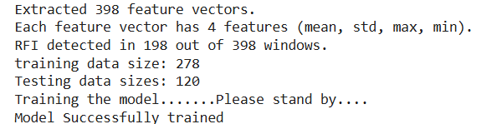
Model Evaluation
The trained model's performance was assessed on the unseen X_test data:
- Predictions: The model generated y_pred (predicted labels) for the test set.
- Accuracy Score: Calculated the overall percentage of correct predictions.
- Classification Report: Provided detailed metrics including precision, recall, and F1-score for both RFI and non-RFI classes, offering insights into false positives and false negatives.
- Confusion Matrix: A table summarizing true positives, true negatives, false positives, and false negatives, giving a clear picture of the model's classification performance.
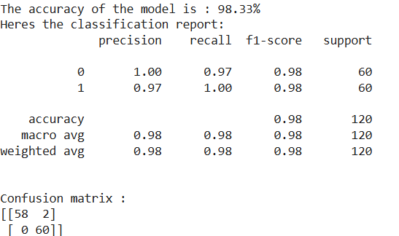
Visualization of Model's Detection
Finally, the trained model was applied to the entire observed_signal (after re-extracting features for all windows). The predicted RFI locations were then mapped back to the original time series. A final plot displayed:
- The original observed_signal.
- The True RFI (Label) from the ground truth.
- The Predicted RFI (Model) from the machine learning model. This visualization allowed for a direct, intuitive comparison of the model's RFI detection capabilities against the known RFI locations.
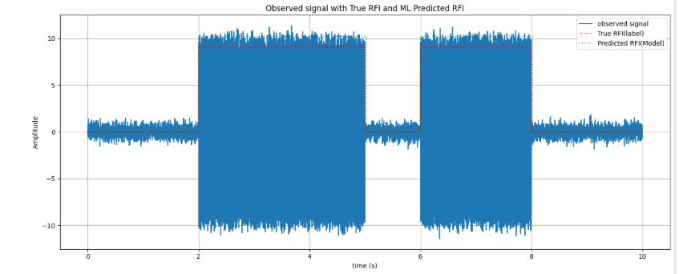
Tools Used
- Python 3: The primary programming language.
- NumPy: For numerical operations, array manipulation, and signal generation.
- Matplotlib: For creating all plots and visualizations.
- Scikit-learn (sklearn): For machine learning functionalities, including data splitting, model training (Logistic Regression), and performance evaluation metrics.
Results and Conclusion
The project successfully demonstrated a basic RFI detection pipeline using a simple machine learning model. The model was able to:
- Accurately distinguish RFI-contaminated signal segments from clean background noise in simulated data.
- Achieve high accuracy and reasonable precision/recall metrics on the test set.
- Visually identify the RFI bursts in the final plot, closely matching the true RFI locations.
This project serves as a foundational step towards understanding and implementing more advanced RFI mitigation techniques, which are critical for the success of modern radio astronomy.
Complete code:
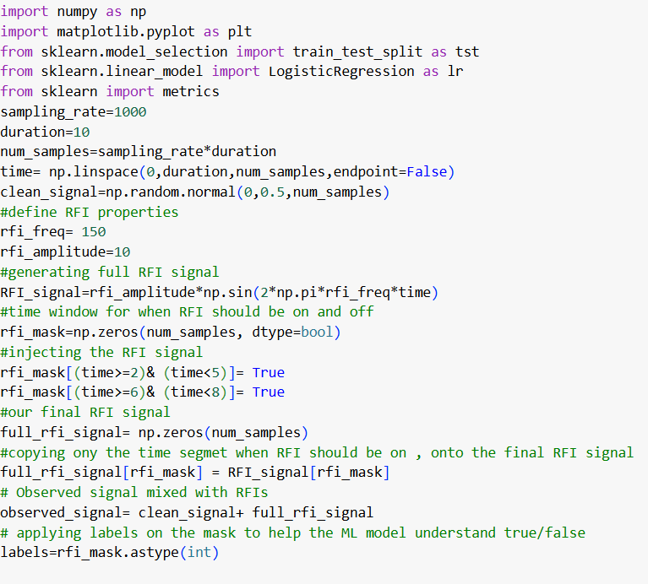
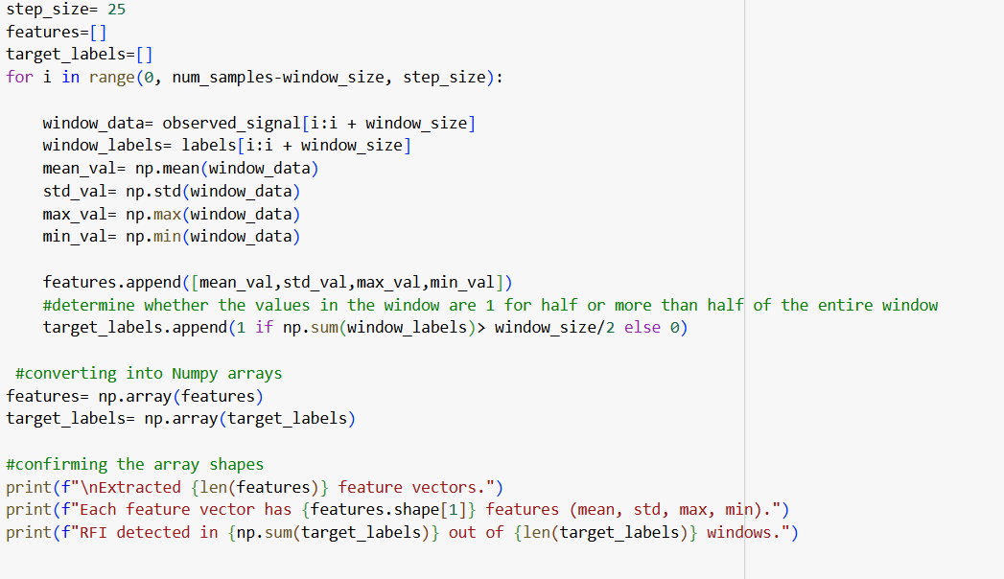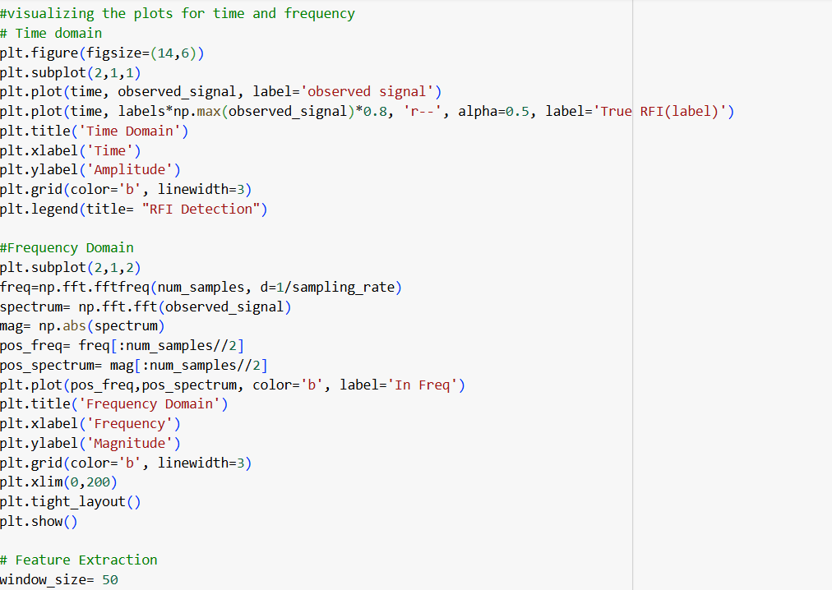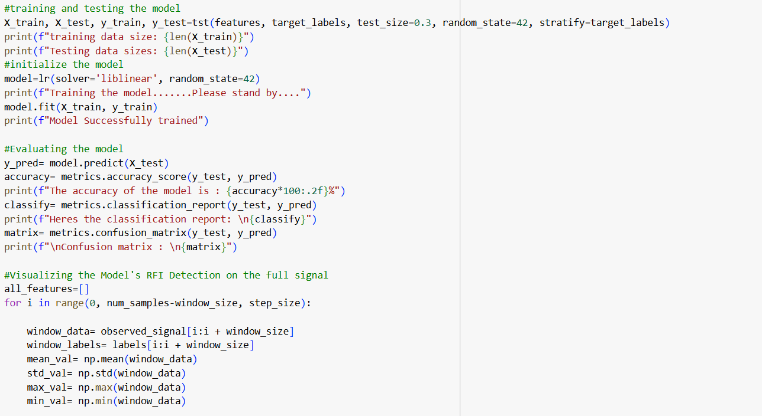
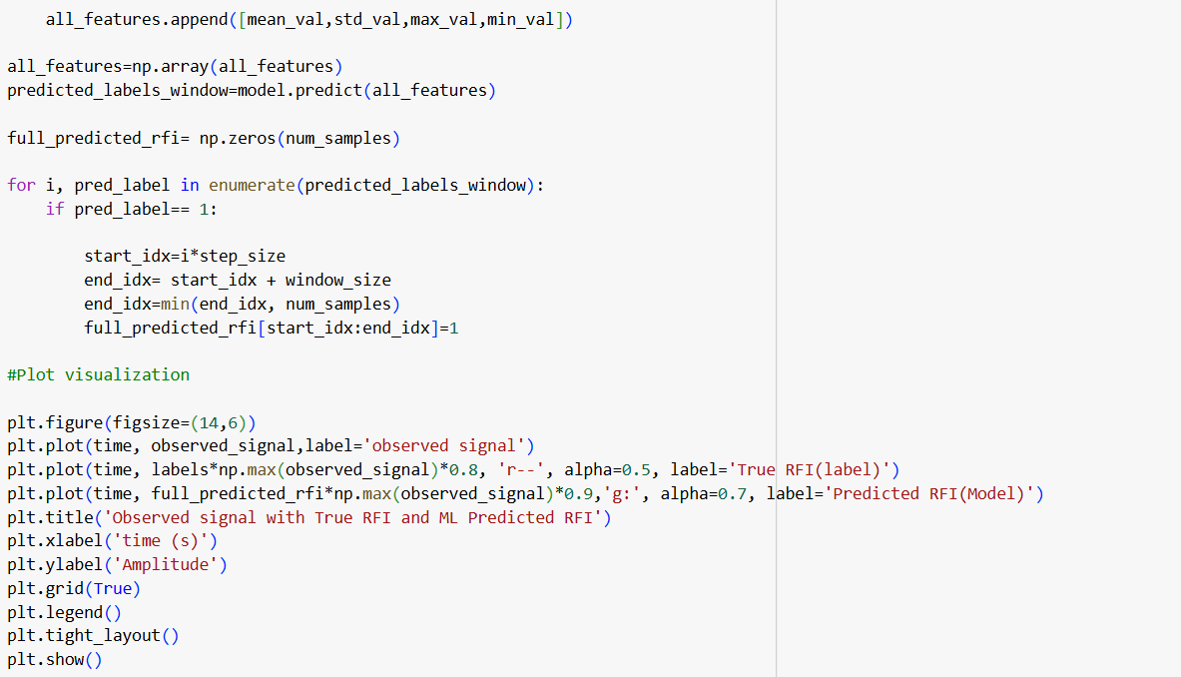

Future Work and Enhancements
- Diverse RFI Simulation: Simulate more complex RFI types (pulsed, broadband, frequency-hopping) to test model robustness.
- Advanced Feature Engineering: Incorporate frequency-domain features (e.g., FFT power in specific bins, spectral kurtosis) or time-frequency features (e.g., from wavelets) to improve detection.
- Explore Different ML Models: Experiment with more sophisticated classifiers like Random Forests, Support Vector Machines, or even basic Neural Networks (using TensorFlow/Keras).
- Hyperparameter Tuning: Optimize window_size, step_size, and model-specific parameters to enhance performance.
- Real Data Integration: Attempt to apply the developed techniques to small, publicly available real radio astronomy datasets (e.g., from NRAO archives), which would involve learning to handle real data formats and complexities.

Link for the colab notebook: https://colab.research.google.com/drive/1k-33gqAvsf1psjfHGMBPC5fhy5dDbSTL#scrollTo=HSO2mAy_oClR
.
.
.
.
.
END OF REPORT

